**Project Design Phase-II**

**Technology Stack (Architecture & Stack)**

|  |  |
| --- | --- |
| Date | 24 June 2025 |
| Team ID | LTVIP2025TMID40098 |
| Project Name | Pollen's Profiling: Automated Classification of Pollen Grains |
| Maximum Marks | 4 Marks |

**Technical Architecture:**

The Deliverable shall include the architectural diagram as below and the information as per the table1 & table 2

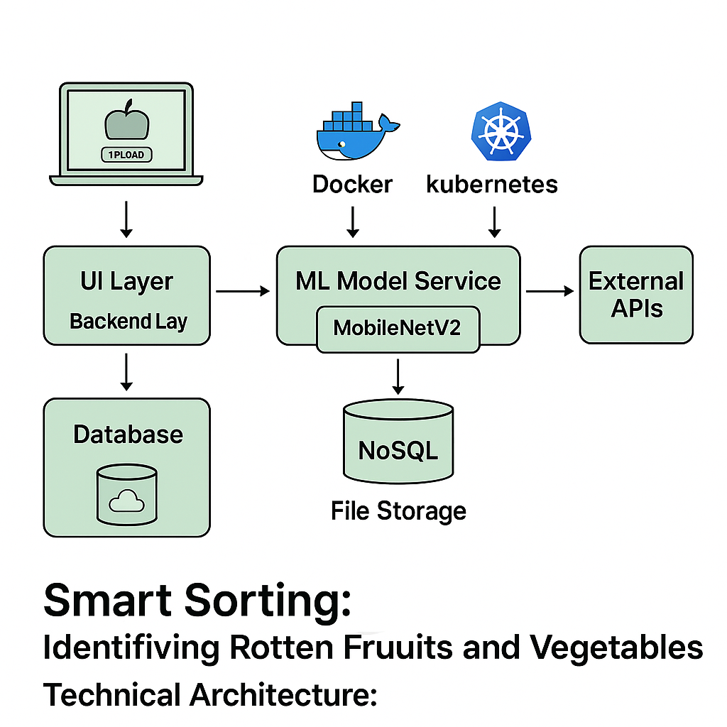

| **S.No** | **Component / Characteristic** | **Description** | **Technology / Approach** |
| --- | --- | --- | --- |
| **1** | **User Interface** | **Web UI for uploading images and showing predictions** | **HTML, CSS, JavaScript, React.js** |
| **2** | **Backend API** | **Handles requests, user authentication, and prediction calls** | **Python (Flask or Django REST Framework), REST APIs** |
| **3** | **Image Processing Pipeline** | **Preprocess and transform images before prediction** | **OpenCV, Pillow** |
| **4** | **Machine Learning Inference** | **Predict fresh vs. rotten produce using trained models** | **TensorFlow / Keras, MobileNetV2 Model Serving** |
| **5** | **Database & Storage** | **Store user data, logs, and uploaded images** | **MongoDB, MongoDB Atlas, AWS S3** |
| **6** | **Security & Authentication** | **Secure data transfer, encrypt information, manage user access** | **SSL/TLS, JWT Authentication, IAM Policies** |
| **7** | **Scalability & Availability** | **Auto-scaling backend services and load balancing** | **Docker, Kubernetes, AWS Load Balancer, Auto-Scaling Groups** |
| **8** | **Performance Optimization** | **Fast predictions, caching, CDN for static content** | **Redis Caching, CloudFront CDN, TensorFlow Model Server** |